Beaumont Dress Code
Jewelry, Hair, & ACCESSORIES Details

Facial Piercings

Facial piercings are NOT permitted under the Beaumont Dress Code.
- NO eyebrow, lip, chin, or cheek piercings of any kind are ever permitted.
- NO covering or camouflaging of any facial piercing is ever permitted
    - (no bandaids, makeup, etc.)

Only ONE small NOSE STUD is permitted and is under the final approval of the administration.
- As a general guide, please use these images:

- PERMITTED (“yes’):
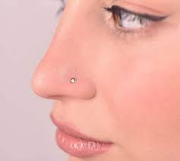

- NOT PERMITTED (“no”):
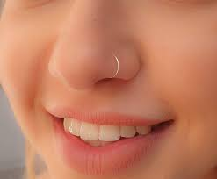 (no rings, hoops, etc.)

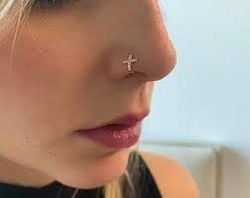 (no designs or extended objects beyond
the circumference of a SMALL round stud)

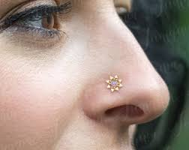 (no designs or extended objects beyond
the circumference of a SMALL round stud)

*See Beaumont Handbook details on the next page (please scroll down):

BEAUMONT STUDENT HANDBOOK section:

From the 2021-2022 Beaumont Student Handbook:

JEWELRY, HAIR, & ACCESSORIES:
All jewelry and accessories must be school-appropriate in nature and are subject to approval by the administration.
- Facial piercings: ONE nose STUD earring is acceptable. No nose rings or septum piercings are permitted.
  - No lip, tongue, eyebrow, or chin piercings or the camouflaging of those piercings are permitted.
  - No earlobe plugs or extenders are permitted.
- Hair: Hair color must be within the range of natural human hair coloring; subtle and without stark contrast.
- Hair Accessories: Headbands (including bandanas or scarves folded & worn as headbands) and hairclips are acceptable.
- NO hats, hoods, bandanas/scarves/head-coverings/headwraps worn to cover the head (except those that are religiously affiliated) are permitted during any school day.
- Tattoos or any skin markings which resemble tattoos must not be visible during the school day or during any Beaumont school-sponsored activity or athletic event.

Beaumont administration reserves the right to determine the appropriateness of student appearance
and to send any non-compliant student home.

